**AMIRDHA S 212221020001**

**EXP 3: Evaluation of Prompting Tools Across Diverse AI Platforms: ChatGPT, Claude, Bard, Cohere Command, and Meta**

**Aim:**

Within a specific use case (e.g., summarizing text, answering technical questions), compare the Performance, user experience, and response quality of prompting tools across these different AI Platforms.

**Prompt:**

Give an python program for to find if a number is even or odd ?

**GEMINI AI**

def is_even(number):

"""Checks if a given number is even.

Args:

number: The number to check.

Returns:

True if the number is even, False otherwise.

"""

return number % 2 == 0

# Get input from the user

num = int(input("Enter a number: "))

# Check if the number is even

if is_even(num):

print(num, "is even.")

else:

print(num, "is odd.")

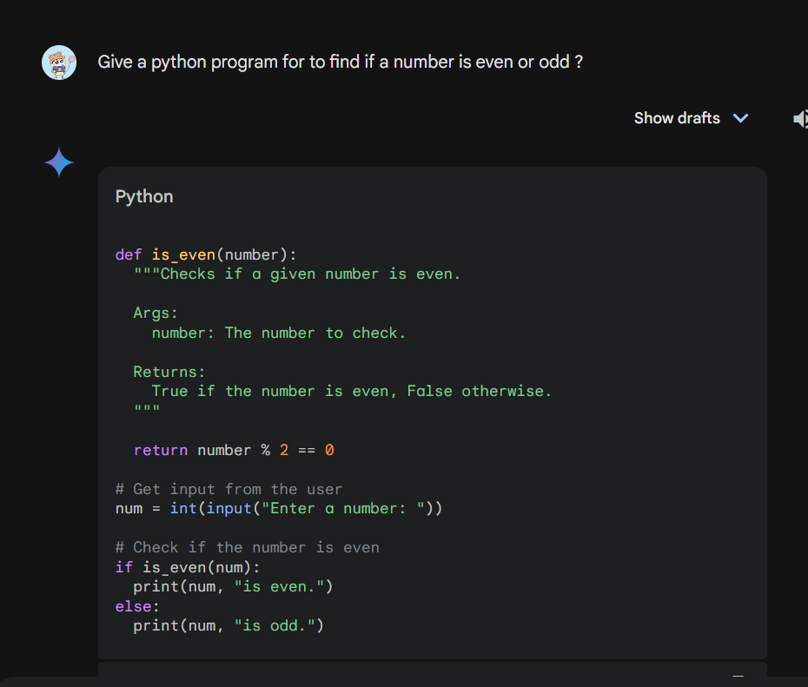

**CHATGPT:**

# Function to check if a number is even or odd

def check_even_odd(number):

if number % 2 == 0:

return f"{number} is even."

else:

return f"{number} is odd."

# Input from the user

try:

user_input = int(input("Enter a number: "))

result = check_even_odd(user_input)

print(result)

except ValueError:

print("Please enter a valid integer.")

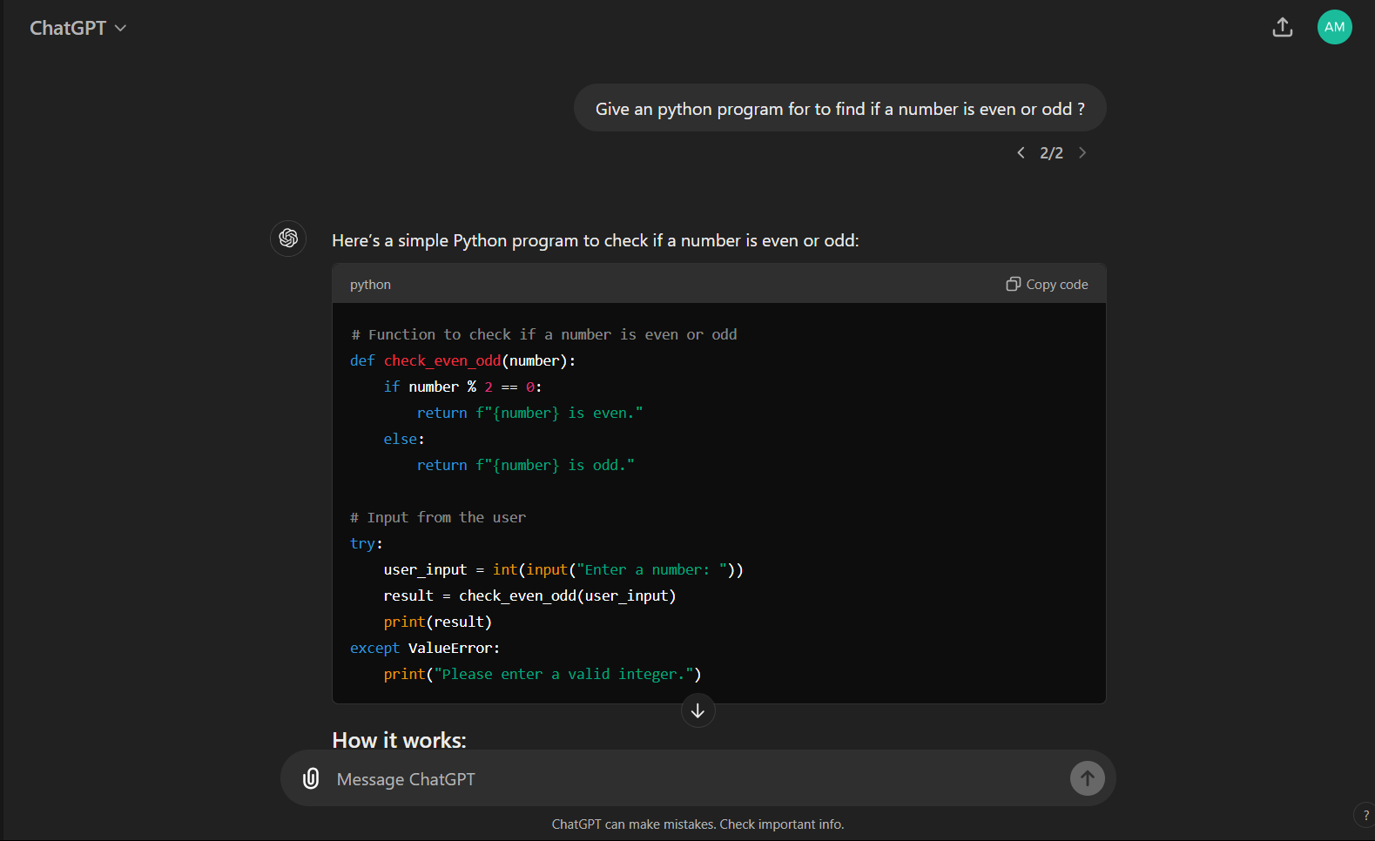

|  |  |  |
| --- | --- | --- |
| Feature | ChatGPT | Gemini AI |
| Development | Developed by OpenAI | Developed by Google DeepMind |
| Capabilities | Strong in text generation and conversation | Focuses on multimodal capabilities and enhanced reasoning |
| Applications | Used in customer service, tutoring, and content creation | Integrated into Google services, enhancing search and personal assistants |

**Summary:**

• ChatGPT:

* Better for creativity, productivity tasks like writing, summarization
* Limited by outdated data without plugins

• Gemini AI:

* Better at answering factual queries and solving technical problems
* Less effective for creative tasks like storytelling

**For the coding Gemini AI is better for use and if you need an definition for the coding ChatGPT is more effective .**

**For the creative task ChatGPT is more effective than the Gemini AI.**